**Crimson College of Technology**

**Pokhara University**



**A Final Year Project Report on**

**“GreenBasket”**

**‘A Full-Stack E-commerce Platform for Eco-Friendly Shopping’**

(PRJ 493)

*In Partial Fulfilment of the Requirements for the*

*Bachelor of Computer Information System (BCIS)****)***

**Under the Supervision of**

**Mr. Chiranjivi Regmi**

**Submitted to:**

**Crimson College of Technology**

Department of Management

**Submitted By:**

**Abhishek Pandey (Symbol No: 21080199)**

**Mohan Pokhrel (Symbol No: 21080224)**

**Prakash Dhawal (Symbol No: 21080227)**

**Shahil Bhusal (Symbol No: 21080236))**

**Aug, 2025**

**Project Approval Sheet**

The project titled "**GreenBasket**" submitted by Abhishek Pandey (21080199), Mohan Pokhrel (21080224), Prakash Dhawal (21080227), and Shahil Bhusal (21080236) has been approved in partial fulfillment for the award of the degree of Bachelor of Computer Information System (BCIS), Crimson College of Technology, Pokhara University.

**__________________ __________________**

**Internal Examiner External Examiner**

**Date: Date:**

# SUPERVISOR’S RECOMMENDATION

I hereby recommend that this report, entitled “**GreenBasket**”, has been prepared under my supervision by Abhishek Pandey (21080199), Mohan Pokhrel (21080224), Prakash Dhawal (21080227), and Shahil Bhusal (21080236) in partial fulfilment of the requirements for the degree of Bachelor of Computer Information System (BCIS) be processed for evaluation.

……...................................

**Mr. Chiranjivi Regmi**

Project Supervisor

Lecturer, BCIS

Crimson College of Technology

# ACKNOWLEDGEMENT

# 

We express our sincere gratitude to **Crimson College of Technology, Pokhara University**, for their invaluable resources and consistent support throughout our project. The college's commitment to academic excellence has significantly influenced our educational journey, and we deeply appreciate the tools and guidance provided.

We would like to extend our heartfelt gratitude to our respected supervisor, **Mr. Chiranjivi Regmi**, for his invaluable guidance, continuous encouragement, and unwavering support throughout the project. His insightful feedback and expertise have played a critical role in the successful completion of **GreenBasket**.

Our special thanks go to our Head of Department, **Mr. Abdul Haq**, for creating a collaborative academic environment and for facilitating a workspace conducive to innovation and teamwork. We are also grateful to all our respected faculty members for their knowledge and encouragement during the course of this project.

We sincerely appreciate the support and feedback from our peers and colleagues, who actively participated in testing and provided valuable suggestions that helped us enhance and refine our application.

We warmly welcome any constructive feedback or suggestions for further improvement.

Abhishek Pandey (21080199)  
 Mohan Pokhrel (21080224)  
 Prakash Dhawal (21080227)  
 Shahil Bhusal (21080236)

# ABSTRACT

GreenBasket is a modern, full-stack e-commerce web application built to promote eco-friendly and sustainable shopping in Nepal. It serves as a centralized platform where users can explore a curated range of environmentally conscious products, including hemp bags, hemp oils, artisan crafts, and other eco-friendly items. The platform is designed to support ethical consumption by connecting environmentally aware consumers with responsible local producers.

The application is developed using cutting-edge technologies such as Next.js for the frontend and backend, Tailwind CSS for responsive design, Clerk for secure authentication, MongoDB Atlas for cloud-based data management, Cloudinary for optimized image handling, and Inngest for background task automation. A unified Seller Dashboard serves as the admin panel, allowing authorized users to upload and manage product listings efficiently.

GreenBasket offers a clean, intuitive, and responsive user interface optimized for both desktop and mobile browsers. Through its focus on sustainability, performance, and usability, GreenBasket contributes to the growing movement of conscious consumerism by providing a streamlined and impactful digital shopping experience tailored to the needs of modern Nepali users.

**TABLE OF CONTENTS**

SUPERVISOR’S RECOMMENDATION i

ACKNOWLEDGEMENT ii

ABSTRACT iii

LIST OF FIGURES vi

LIST OF TABLES vii

LIST OF ABBREVIATIONS viii

Chapter 1: Introduction 1

1.1 Introduction 1

1.2 Problem Statement 1

1.3 Objectives 2

1.4 Scope and Limitations 3

1.4.1 Scope 3

1.4.2 Limitations 3

1.5 Development Methodology 4

Chapter 2: Contextual and Literature Review 6

2.1 Background Study 6

2.2 Literature Review 7

2.2.1 Study of existing systems 8

Chapter 3: System Analysis 9

3.1 System Analysis 9

3.1.1 Requirement Analysis 9

ii) Non-Functional Requirements: 15

3.1.2 Feasibility Analysis 15

i) Technical Feasibility: 16

ii) Economic Feasibility: 16

iii) Operational Feasibility: 16

iv) Schedule Feasibility: 16

3.1.3 Analysis 17

i) ER Diagram 17

ii) Sequential Flowchart 18

iii) Sequence Diagram 20

Chapter 4: System Design 22

4.1 Design 22

4.1.1 System Diagram 22

4.1.2 Context Diagram 23

Chapter 5: Implementation And Testing 24

5.1 Implementation 24

5.1.1 Tools Used 24

5.2 Testing 25

5.2.2 Test Cases for System Testing 29

5.3 Result Analysis 30

Chapter 6: Conclusion And Future Enhancements 31

6.1 Conclusion 31

6.2 Future Enhancements 31

References 34

Appendix 36

# LIST OF FIGURES

Figure 1. 1 Agile Development Model 5

Figure 3. 1 Flowchart for Admin 11

Figure 3. 2 ER Diagram 17

Figure 3. 3 Sequential Flowchart for Admin 18

Figure 3. 4 Sequential Flowchart for Users 19

Figure 3. 5 Sequence Diagram 21

Figure 4.1 System Diagram………………………………………………………………22

Figure 4. 2 Context Diagram ……………………………………………………………23

# 

# LIST OF TABLES

Table 3. 1 Register Use Case Description 12

Table 3. 2 Use Case Description on (Admin/seller) 13

Table 3. 3 Use Case Description of Admin (Add Product) 13

Table 3. 4 Login Use Case Description (Customer) 14

Table 3. 5 Use Case Description of Customer (Purchase Product) 14

Table 5. 1 Test case for User Login 26

Table 5. 2 Test case for Admin Login 27

Table 5. 3 Test case for User Registration 28

Table 5. 4 Test Case for System Testing 29

Table 5. 5 Test Case for System Usability Testing 29

Table 5. 6 Test Case for Admin Functionality 30

# LIST OF ABBREVIATIONS

API Application Programming Interface

CSS Cascading Style Sheet

DB Database

HTML Hypertext Markup Language

JS JavaScript

SQL Structured Query Language

UI User Interface

# Chapter 1: Introduction

## 1.1 Introduction

GreenBasket is a web-based e-commerce application developed as part of our final year project for the Bachelor of Computer Information System (BCIS) program. The main goal of this project is to promote eco-friendly and sustainable shopping in Nepal by providing a platform where users can easily view and explore products such as hemp bags, hemp oils, artisan crafts, and other eco-friendly items.

In today’s digital age, e-commerce has become an essential part of daily life. However, most existing platforms focus on commercial goods and often overlook the growing demand for sustainable and environmentally conscious products. GreenBasket addresses this gap by offering a dedicated space for ethical sellers to showcase eco-friendly products and for customers to make informed, environmentally responsible choices.

The platform is built using modern technologies including **Next.js**, **Tailwind CSS**, **Clerk**, **MongoDB Atlas**, **Cloudinary**, and **Inngest**. It features a responsive user interface that adapts to both desktop and mobile devices. A single **Seller Dashboard** is implemented, which also functions as the admin panel, allowing sellers to manage product listings and images efficiently. Users can register, log in, and browse products, with the interface designed to be clean, minimal, and easy to navigate.

GreenBasket aims to raise awareness about sustainable consumption while also providing a learning opportunity for us to apply full-stack web development skills in a real-world project. Through this platform, we seek to demonstrate how technology can be used to support local producers and encourage eco-conscious behavior in Nepal.

## 1.2 Problem Statement

In Nepal, the market for eco-friendly and sustainable products is steadily growing, but access to these products remains limited and unorganized. Many ethical and local producers offer high-quality environmentally conscious goods such as hemp-based products and handcrafted items. However, due to the lack of a centralized and dedicated platform, these sellers struggle to reach a wider audience. Similarly, customers who are interested in purchasing sustainable goods often face difficulties in finding trusted sources or browsing eco-friendly options in one place.

Most existing e-commerce platforms prioritize general commercial goods and do not focus on environmentally sustainable products. As a result, both buyers and sellers face challenges — buyers cannot easily find what they are looking for, and sellers cannot effectively promote their eco-conscious items to a relevant customer base.

There is a clear need for a dedicated web-based system that promotes sustainable shopping and connects consumers with local ethical sellers. Such a platform should provide a responsive, easy-to-use interface where users can explore and learn about eco-friendly products, while also allowing sellers to manage and present their items effectively.

The GreenBasket project aims to address these challenges by creating a digital platform that bridges the gap between environmentally aware consumers and producers of sustainable goods, encouraging a shift toward conscious consumerism in Nepal.

## 1.3 Objectives

The primary objective of the GreenBasket project is to design and develop a web-based e-commerce platform that promotes eco-friendly and sustainable shopping in Nepal.

The specific objectives of the project are as follows:

* To develop a responsive and accessible web application that supports eco-friendly online shopping.
* To provide a platform where sellers can upload and manage products such as hemp bags, hemp oils, and artisan crafts.
* To implement a secure user authentication system using Clerk for account creation, login, and session management.
* To integrate modern backend technologies such as MongoDB Atlas for data storage and Inngest for background processing tasks.
* To deploy the application on a reliable cloud hosting service (Vercel) for high performance and scalability.

## 1.4 Scope and Limitations

### 1.4.1 Scope

The GreenBasket project is focused on developing a fully responsive, full-stack e-commerce web application that promotes eco-friendly shopping in Nepal. The platform allows users to view a curated selection of sustainable products such as hemp bags, hemp oils, and locally handcrafted items. It is designed to function efficiently on both desktop and mobile browsers, providing accessibility across devices.

The platform supports two main user types:

* **Users (Customers):** Can register or log in using Clerk, and view eco-friendly products categorized by type. Users can browse through detailed product listings with images, titles, and prices.
* **Sellers:** Have access to a Seller Dashboard, which also acts as the admin panel. From this interface, sellers can add new products, upload multiple images via Cloudinary, and manage their listings, including adding product descriptions, actual price, offer price, and selecting categories from a predefined list. Sellers can also view all product listings and customer orders.

The backend is powered by Next.js, MongoDB Atlas, and Inngest, enabling dynamic rendering, secure data storage, and efficient background event handling. The project is hosted on Vercel, ensuring reliable performance, automatic deployment, and scalability.

### 1.4.2 Limitations

Although GreenBasket provides a solid foundation for an eco-commerce platform, the current version of the project has the following limitations:

* **No Online Payment Integration:** Due to the unavailability of eSewa and Khalti testing APIs, online payment options are not yet implemented. Orders are currently limited to a viewing-only experience.
* **No Filtering:** Users cannot filter products by price, category, or keywords.
* **No Product Quantity Specification:** Sellers cannot specify product quantity when adding or managing products, and users cannot select quantities when viewing products.
* **No Customer Reviews or Ratings:** There is no mechanism for users to leave feedback on products or sellers.
* **Single Language Support:** The platform is developed only in English, limiting accessibility for non-English-speaking users.

## 1.5 Development Methodology

For the development of GreenBasket, we adopted the **Agile development methodology** due to its flexibility, iterative nature, and focus on continuous improvement. Agile allows the project team to deliver small, functional parts of the application regularly while adapting to feedback and changing requirements throughout the development process.

The development started with planning and gathering basic requirements, followed by dividing the project into multiple sprints. Each sprint focused on building specific features such as user authentication, product management, and responsive UI design. At the end of each sprint, the working version of the application was reviewed and tested by the team and project supervisor.

This iterative approach helped identify and fix issues early, ensuring steady progress and quality control. Feedback from each review was incorporated into the next sprint, allowing improvements and refinements to be made continuously. Agile also encouraged close collaboration among team members, fostering effective communication and problem-solving.

By following the Agile methodology, we ensured that GreenBasket was developed in a structured yet adaptable way, enabling us to meet project goals efficiently while maintaining a high standard of functionality and user experience.

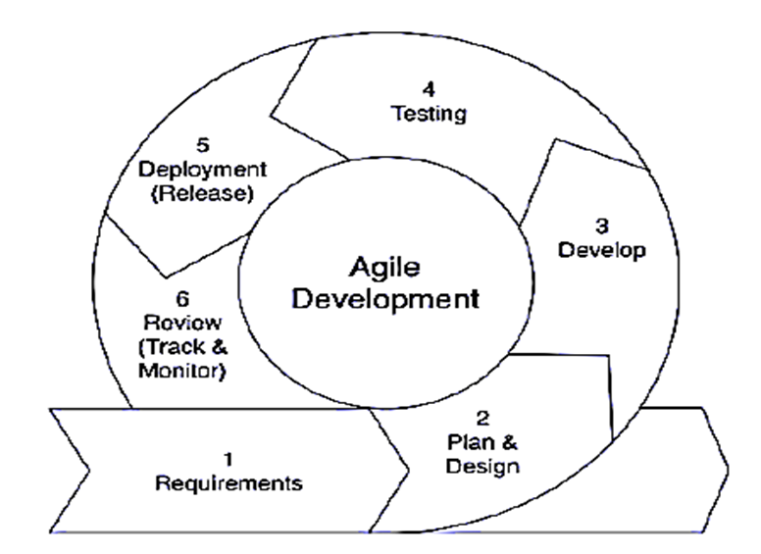

**Figure 1. 1** **Agile Development Model**

In summary, the Agile Development Model allows us to build a more user-friendly and effective GreenBasket platform. By working iteratively and incorporating feedback at every step, we ensure that our final product will be well-suited to help consumers and sellers in Nepal find and manage sustainable and eco-friendly products more efficiently.

# Chapter 2: Contextual and Literature Review

## 2.1 Background Study

The global demand for eco-friendly and sustainable products has increased significantly as consumers become more conscious of environmental impact and ethical sourcing. Sustainable shopping promotes the reduction of waste, the use of natural materials, and support for local artisans, contributing to environmental conservation and social responsibility [1].

E-commerce platforms have revolutionized how consumers access products, but most existing marketplaces prioritize mass-produced goods over sustainable alternatives. Platforms like Etsy and EarthHero have successfully created niches for eco-conscious consumers by offering handmade, organic, and ethically sourced products, illustrating the market potential for specialized eco-commerce sites [2].

In Nepal, however, the market for eco-friendly products remains fragmented and underdeveloped. While some local businesses offer sustainable goods such as hemp-based items and handmade crafts, consumers face difficulty finding these products in a single, trustworthy online platform [3]. Existing general marketplaces do not focus specifically on eco-consciousness, leading to limited visibility for sustainable products and producers.

GreenBasket aims to address this gap by providing a dedicated, user-friendly e-commerce platform focused exclusively on sustainable and eco-friendly products. By leveraging modern web technologies, the platform seeks to connect conscious consumers with local sellers who offer environmentally responsible products, promoting sustainable consumption patterns in Nepal.

Furthermore, the project aligns with global sustainability goals by encouraging the use of natural materials and supporting local artisans, thereby contributing to environmental protection and economic empowerment. The GreenBasket platform represents a step towards digital transformation in Nepal’s green market sector, providing both educational and commercial value.

## 2.2 Literature Review

The rise of digital platforms and growing environmental awareness have fueled interest in sustainable e-commerce and conscious consumerism. This review examines current research and trends to identify challenges and opportunities in building an online marketplace for eco-friendly products in Nepal. GreenBasket seeks to address existing gaps and improve ethical consumption systems.

Research consistently highlights a growing consumer preference for sustainable products and a willingness to support businesses with transparent and ethical practices [4]. Studies on sustainable consumer behavior emphasize factors influencing purchasing decisions, such as environmental impact awareness, eco-labeling, and perceived effectiveness of individual actions [5]. This indicates that a successful sustainable e-commerce platform must not only offer desirable products but also build strong trust and provide clear information.

Globally, the e-commerce sector is increasingly integrating sustainability into its core operations, driven by both consumer demand and competitive advantage. Key success factors for online platforms selling eco-friendly products include ethical sourcing, transparency in supply chains, use of sustainable packaging, and clear communication of environmental impact [6]. Furthermore, the role of digital technologies in facilitating sustainable practices is well-documented. Technologies like robust authentication systems (e.g., Clerk), efficient image handling (e.g., Cloudinary), and scalable database management (e.g., MongoDB Atlas) are critical in building trust, enhancing user experience, and managing the vast product information required for ethical transparency in e-commerce [7]. These technologies underpin the ability of platforms to provide detailed product information, track origins, and manage logistics with a view toward reducing environmental footprint.

Despite the growing global trend and the burgeoning e-commerce market in Nepal, a significant gap exists in specialized online platforms for sustainable products. While general e-commerce platforms operate, they typically lack the focus, verification mechanisms, and detailed product narratives crucial for genuine sustainable shopping [8]. Consumers in Nepal often struggle with verifying the authenticity of "eco-friendly" claims, leading to skepticism and hindering the adoption of sustainable alternatives. This literature review underscores the need for a dedicated platform like GreenBasket, which can leverage modern web technologies to bridge this trust deficit and offer a curated marketplace that aligns with the specific cultural and environmental values of Nepal. By learning from the challenges and successes documented in the broader e-commerce and sustainability literature, GreenBasket aims to create an interactive, trustworthy, and efficient online space for conscious consumers in Nepal.

### 2.2.1 Study of existing systems

The evolving digital landscape in Nepal has seen the rise of several e-commerce platforms, transforming traditional retail. While these platforms have made online shopping more accessible, a detailed review reveals significant gaps in their approach to genuinely sustainable and eco-friendly products. GreenBasket aims to fill this void by offering a specialized and transparent platform.

Some of the prominent existing e-commerce platforms in Nepal include:

* **Daraz Nepal:** As the largest e-commerce platform in Nepal, Daraz offers a vast array of products across numerous categories, including electronics, fashion, and home goods. It provides a robust marketplace model with extensive logistics and a wide customer base. However, its primary focus is on mass-market consumption, and while some sellers may offer "eco-friendly" items, Daraz does not specialize in, nor does it extensively verify or highlight the sustainable credentials of these products. Consumers often lack detailed information regarding ethical sourcing, environmental impact, or certifications for such items [9].
* **HamroBazar:** Operating more as a classified advertisements platform, HamroBazar facilitates buying and selling of new and used items directly between consumers. While it offers a wide variety of goods, its classified nature means there is minimal oversight on product authenticity, sustainability claims, or quality. It serves a broad general market and lacks the curated experience and verification crucial for a platform dedicated to eco-friendly products [10].
* **Thulo.com:** Thulo.com is another expanding e-commerce platform offering a diverse range of products, including groceries, electronics, and health and beauty items. Similar to Daraz, Thulo.com provides a convenient shopping experience but does not possess a specialized focus on sustainable products, nor does it deeply integrate features that highlight ethical production or environmental benefits [11].

# Chapter 3: System Analysis

## 3.1 System Analysis

The system analysis for **GreenBasket** focuses on identifying and defining the functional and non-functional requirements needed to build an efficient, secure, and user-friendly eco-friendly e-commerce platform. The analysis involves key stakeholders including customers who browse and shop sustainable products, the seller/admin managing product listings and orders, and the system itself ensuring smooth authentication, data management, and user experience.

### 3.1.1 Requirement Analysis

The following are the functional and non-functional requirements for the GreenBasket system, specifically detailing user roles and authentication using Clerk:

**i) Functional Requirements:**

**Authentication and User Account Management (via Clerk):**

* **Sign Up:** Users can create a new account using their email address, including Google sign-in.
* **Login:** Users can log in using their registered email and password or via Google.
* **Profile Management:** All users (Customers and Admin/Seller) can manage their personal profile, including adding new email addresses, updating profile information (e.g., name), setting/changing passwords, and initiating account deletion, all utilizing Clerk's built-in functionalities.
* **Role Assignment:** The system explicitly assigns the 'seller' role to the email shahil.bhusal3697@gmail.com. All other registered users are assigned the 'customer' role by default.

**Customer (Buyer) Roles:**

* **Product Browse:** View popular products on the homepage. Go to a general Shop page that lists all products together or can search product by name or category.
* **Product Viewing:** Customers can view detailed product descriptions, multiple high-quality images (managed by Cloudinary), current pricing, and any offer prices.
* **Shopping Cart:** Customers can add desired products to their shopping cart, review cart contents, adjust quantities of items, and remove items before checkout.
* **Checkout Process:** Customers can proceed to a streamlined checkout.
* **Order History:** Customers can view a comprehensive history of their past orders.

**Admin/Seller Roles (Assigned only to shahil.bhusal3697@gmail.com):**

* **Seller Dashboard Access:** Upon successful login with the assigned seller email, the user gains access to the dedicated Admin/Seller dashboard.
* **Product Addition:** The Admin/Seller can add new product listings by providing:
  + Product image(s) (uploaded via Cloudinary).
  + Product name.
  + Detailed product description.
  + Category selection from predefined options: 'Hemp Bag', 'Hemp Oil', 'Local Artisan’, 'Eco-Friendly'.
  + Product price.
  + Offer price.
* **Product List Viewing:** The Admin/Seller can view a comprehensive list of all products currently available on the platform.
* **Product Deletion:** The Admin/Seller can delete products from the platform using the delete button available at the right side of every product on the product list page.
* **Order Viewing:** The Admin/Seller can view a list of all customer orders placed on the platform.

**System Roles:**

* **User Authentication & Authorization:** Clerk securely handles user authentication (login/signup) and manages authorization based on assigned roles to control access to specific functionalities (e.g., seller dashboard vs. customer features).
* **Product Inventory Management:** The system automatically tracks and updates product stock levels based on purchases and new additions.
* **Image Handling:** Manages multi-image uploads, storage, optimization, and delivery for all product listings using Cloudinary.
* **Background Processing:** Utilizes Inngest to handle asynchronous and scheduled tasks, ensuring smooth operation without impacting user experience (e.g., processing order confirmations, data synchronization).
* **Data Storage:** All product, user, and order data are securely stored and managed in MongoDB Atlas.

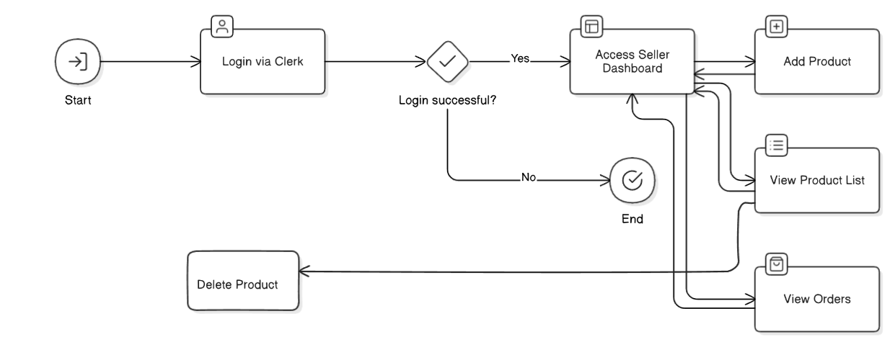

**Figure 3. 1 Flow Chart for Admin**

The diagram outlines the use case flow for the "Admin" actor in the Green Basket project. It begins with a login via Clerk, followed by a check to determine if the login is successful, which then directs the process accordingly.

**Use Case Description:**

**Table 3. 1 Register Use Case Description**

|  |  |
| --- | --- |
| Use Case Name | Register |
| Scenario | Create user account (for Customer or Admin/Seller) |
| Triggering event | User initiates registration process |
| Brief description | User should be able to create a new account in GreenBasket to access features. Authentication is handled by Clerk, including Google sign-in. If shahil.bhusal3697@gmail.com registers, they are assigned the seller role; otherwise, they are a customer. |
| Actors | Customer (Buyer), Admin/Seller |
| Related use cases | Login |
| Stakeholders | Customers, Admin/Seller |
| Preconditions | User accesses the GreenBasket platform. |
| Postconditions | A new user account is successfully created and authenticated via Clerk, with the appropriate role assigned based on the email address. |
| Flow of Activities | 1. The user accesses the Registration page.  2. The user enters their email address and password (or uses Google sign-in).  3. Upon submission, Clerk processes the registration and creates the account.  4. The system assigns the appropriate role (customer or seller) and redirects the user to the relevant dashboard or homepage. |
| Exception conditions | User provides incomplete or invalid information; email already exists; system displays a suitable error message. |

**Table 3. 2 Login Use Case Description (Admin/Seller)**

|  |  |
| --- | --- |
| Use Case Name | Login |
| Actors | Admin/Seller |
| Preconditions | Account (specifically shahil.bhusal3697@gmail.com) is registered in the system. |
| Primary Path | Enter shahil.bhusal3697@gmail.com as Email address  - Enter Password  - Click on Login  - System verifies credentials via Clerk and grants access to Seller Dashboard. |
| Exception conditions | Invalid Credentials; system displays an error message. |

**Table 3. 3 Use Case Description of Admin/Seller (Add Product)**

|  |  |
| --- | --- |
| Use Case Name | Add Product |
| Actors | Admin/Seller |
| Preconditions | Admin/Seller (shahil.bhusal3697@gmail.com) is logged in and has access to the seller dashboard. |
| Primary Path | - Admin/Seller navigates to the 'Add Product' section on the dashboard.  - Fills in product details: name, description, price, offer price (optional).  - Selects category from: Hemp Bag, Hemp Oil, Local Handcrafted Goods, Eco-Conscious Items.  - Uploads product image(s) via Cloudinary.  - Clicks 'Submit' to add the new product. |
| Exception conditions | Required fields are missing; invalid image format; network error during image upload; system displays suitable error message. |

**Table 3. 4 Login Use Case Description (Customer/Buyer)**

|  |  |
| --- | --- |
| Use Case Name | Login |
| Actors | Customer (Buyer) |
| Preconditions | Customer account is registered in the system. |
| Primary Path | - Enter Email address  - Enter Password  - - Click on Login  - System verifies credentials via Clerk and grants access to the customer shopping interface |
| Exception conditions | Invalid Credentials; system displays an error message. |

**Table 3. 5 Use Case Description of Customer (Purchase Product/Checkout)**

|  |  |
| --- | --- |
| Use Case Name | Purchase Product / Checkout |
| Actors | Customer (Buyer) |
| Preconditions | Customer is logged in and has one or more items in their shopping cart. |
| Primary Path | - Customer navigates to the Shopping Cart.  - Reviews selected items, adjusts quantities if needed.  - Proceeds to the Checkout process.  - Confirms order details  - Order is placed. |
| Exception conditions | Shopping cart is empty; empty shipping information provided; system displays suitable error message. |

#### ii) Non-Functional Requirements:

The non-functional requirements for GreenBasket are as follows:

* **Security:** Robust security measures, including Clerk for all authentication and user management, must be implemented to protect all user data and transaction information. Data stored in MongoDB Atlas will be secured with appropriate access controls.
* **Usability:** The platform should be highly user-friendly with an intuitive and consistent interface, ensuring ease of navigation and a smooth shopping experience for customers and efficient product/order management for the Admin/Seller.
* **Performance:** GreenBasket must exhibit quick page load times, and efficient processing of all user and admin actions to ensure a seamless experience, leveraging Next.js's performance optimizations and Cloudinary for image delivery.
* **Reliability:** The system should be highly reliable, operating with minimal downtime and consistent performance across all features, ensuring continuous availability for users in Nepal.
* **Maintainability:** The system will be designed with a modular and clean architecture (Next.js, Tailwind CSS) to facilitate easy maintenance, future updates, and the addition of new features without significant disruptions.
* **Scalability:** The underlying architecture (Next.js, MongoDB Atlas, Cloudinary, Inngest, Clerk) is chosen to ensure the platform can scale effectively to handle a growing number of users, products, and transactions as GreenBasket expands its reach.

### 3.1.2 Feasibility Analysis

The feasibility study for GreenBasket evaluates the practicality and potential benefits of the proposed e-commerce system within Nepalese society and for the organization. It assesses whether the system can be successfully developed and deployed within reasonable constraints of cost, time, and effort, based on the identified requirements.

#### i) Technical Feasibility:

GreenBasket is highly technically feasible, leveraging a modern and robust technology stack. The core tools and technologies selected, including Next.js for frontend and backend, Tailwind CSS for styling, Clerk for authentication, MongoDB Atlas for database management, Cloudinary for image handling, and Inngest for background processes, are industry-standard, well-documented, and benefit from extensive community support. These technologies offer high scalability, security features, and are well-suited for developing a full-stack e-commerce web application. The necessary hardware requirements, such as development computers, deployment servers (like Vercel), and network infrastructure, are readily available and align with current web development best practices. The chosen stack ensures that the project can be built with efficiency and reliability, setting a strong technical foundation.

#### ii) Economic Feasibility:

Economically, the project stayed within the planned budget by leveraging free-tier services and open-source technologies. No significant unexpected costs occurred during development. The use of cloud services like MongoDB Atlas and Cloudinary minimized infrastructure expenses. The project demonstrated potential for future monetization through eco-friendly product sales, although the current version does not yet include payment integration. Thus, the project was economically viable as intended.

#### iii) Operational Feasibility:

Operationally, GreenBasket functioned smoothly and fulfilled its intended purpose. The platform’s user interface was accessible and intuitive, facilitating product browsing and account management for users. The single seller/admin dashboard simplified product and order oversight, while Clerk handled secure authentication seamlessly. Users and the admin reported ease of use, indicating strong operational feasibility. Some limitations, such as the absence of search and payment features, were noted for future development but did not impair core operations.

#### iv) Schedule Feasibility:

The project was completed within the targeted 12-week schedule by following an Agile methodology. Iterative development and regular feedback loops helped maintain progress and address issues promptly. The timeline was sufficient to deliver the core functionalities, and the team adhered well to deadlines, demonstrating strong schedule feasibility.

### 3.1.3 Analysis

#### i) ER Diagram

An ER Diagram (Entity-Relationship Diagram) is a visual representation of data and how different data elements (entities) relate to each other in a database system. It is widely used in database design to model the logical structure before actual implementation.

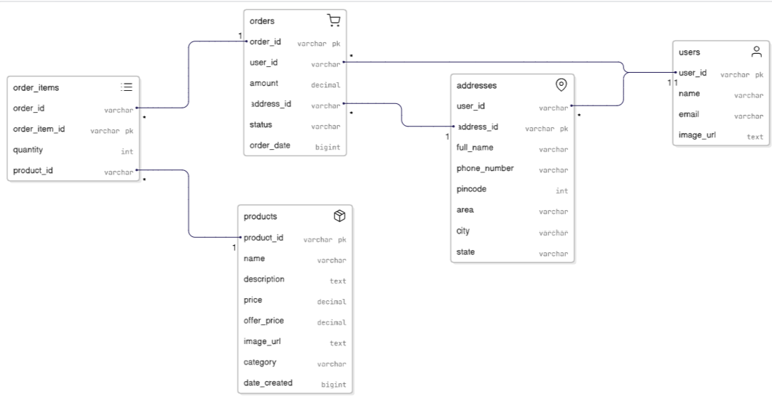

**Figure 3. 2 ER Diagram**

The above ER diagram for the Green Basket project depicts the database structure, showing relationships between entities. It includes "Orders" linked to "Order_Items" (with order_id, quantity, and product_id), "Products" (with product_id, name, description, prices, image_url, category, and date_created), "Addresses" (with address_id, user_id, full_name, phone_number, pincode, area, city, and state), and "Users" (with user_id, name, email, and image_url).

#### ii) Sequential Flowchart

A **Sequential Flowchart** is a type of flowchart that illustrates a linear process where each step follows one after the other in a specific, ordered sequence — without any branching, decision-making, or looping.

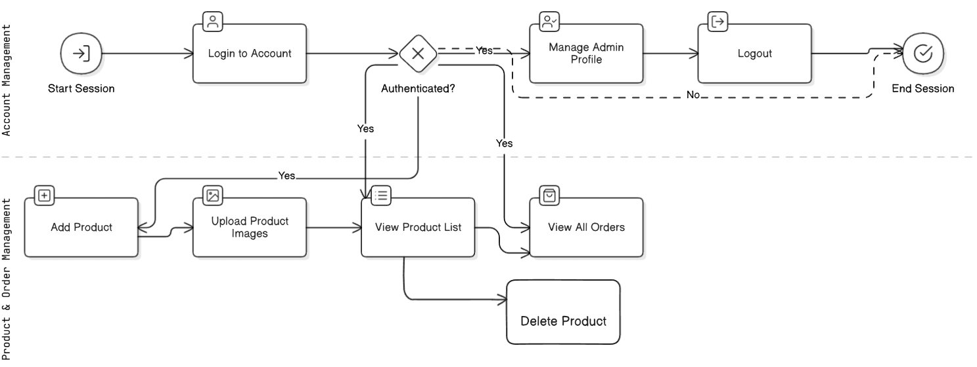

**Figure 3. 3 Sequential Flowchart for Admin**

The above sequential flowchart depicts the workflow for the "Seller" actor in the Green Basket project. It starts with "Start Session" and "Login to Account." Upon successful authentication ("Yes"), the seller can manage their admin profile, add products, upload product images, view the product list and view all orders. If authentication fails ("No"), it loops back to login. The session ends with "Logout" leading to "End Session."

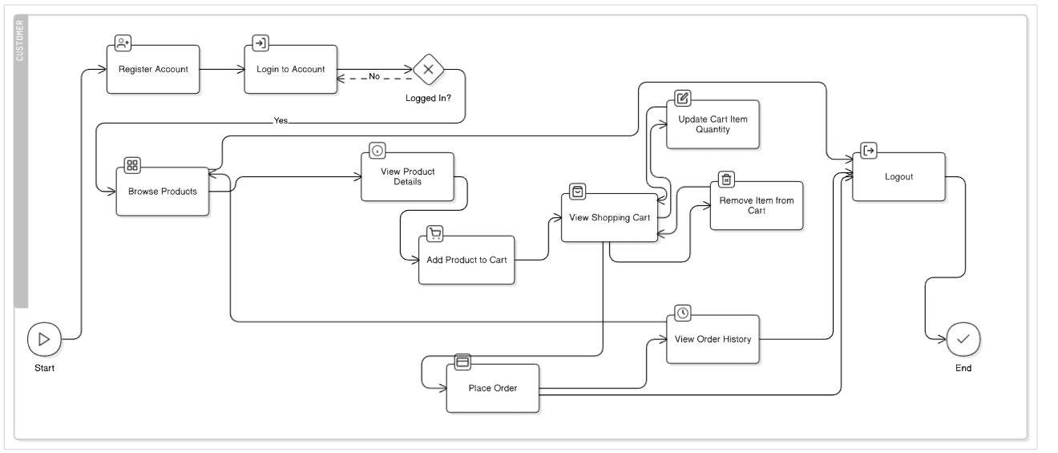

**Figure 3. 4** **Sequential Flowchart for Users**

The above sequential flowchart depicts the workflow for the "Customer" actor in the Green Basket project. It starts with "Start," followed by "Register Account" or "Login to Account." Upon successful login ("Yes"), customers can browse products, view product details, add items to the cart, view the shopping cart, update cart item quantities, remove items from the cart, place an order, view order history, and logout. If login fails ("No"), the process loops back. It ends with "End."

#### iii) Sequence Diagram

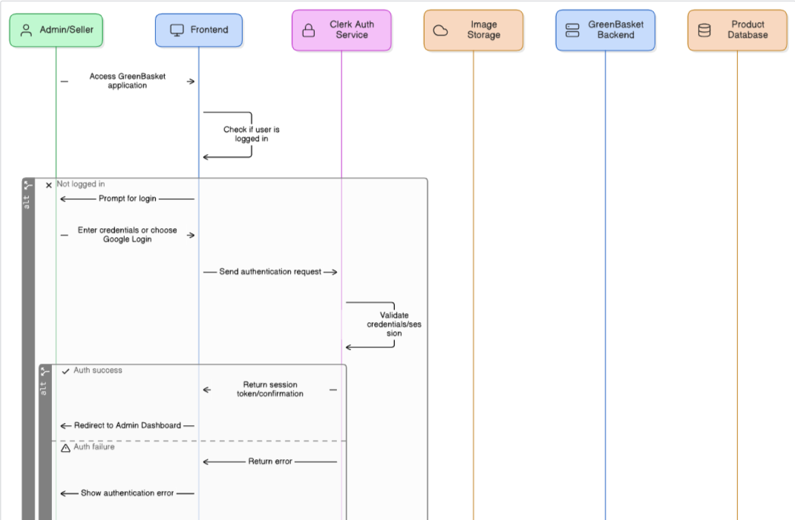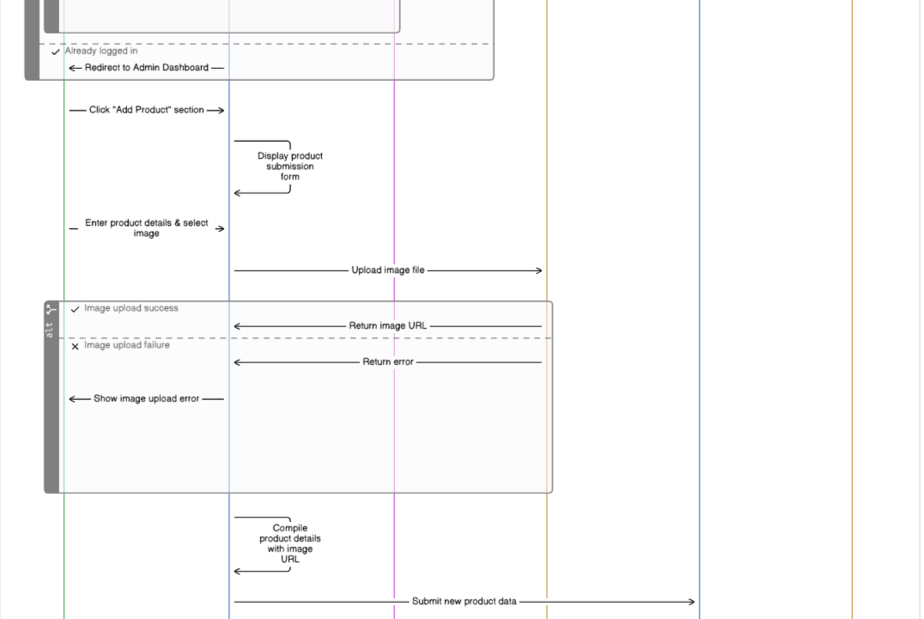

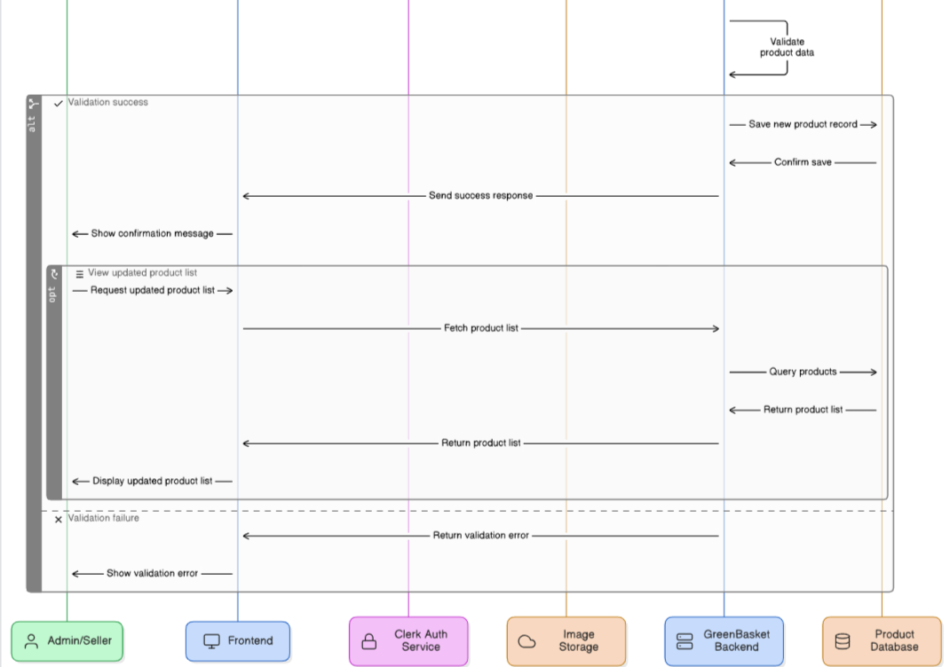

**Figure 3. 5 Sequence Diagram**

The sequence diagram for the Green Basket project depicts the interaction between the Admin/Seller, Frontend, Clerk Auth Service, Image Storage, GreenBasket Backend, and Product Database for adding a product. The process starts with the Admin/Seller accessing the application, logging in via Clerk Auth, and entering product details and an image. Upon successful authentication and image upload, the Frontend displays a product submission form, uploads the image to storage (returning a URL), compiles product data with the image URL, and submits it to the Backend. The Backend validates the data; on success, it saves the product record to the database, sends a confirmation, and updates the product list. On failure, it returns a validation error.

# Chapter 4: System Design

## 4.1 Design

### 4.1.1 System Diagram

A System Diagram is a visual representation of a system's components and their interactions, illustrating how inputs, processes, and outputs are related within the system. It is used in system analysis and design to understand the structure, behavior, and data flow within a system.

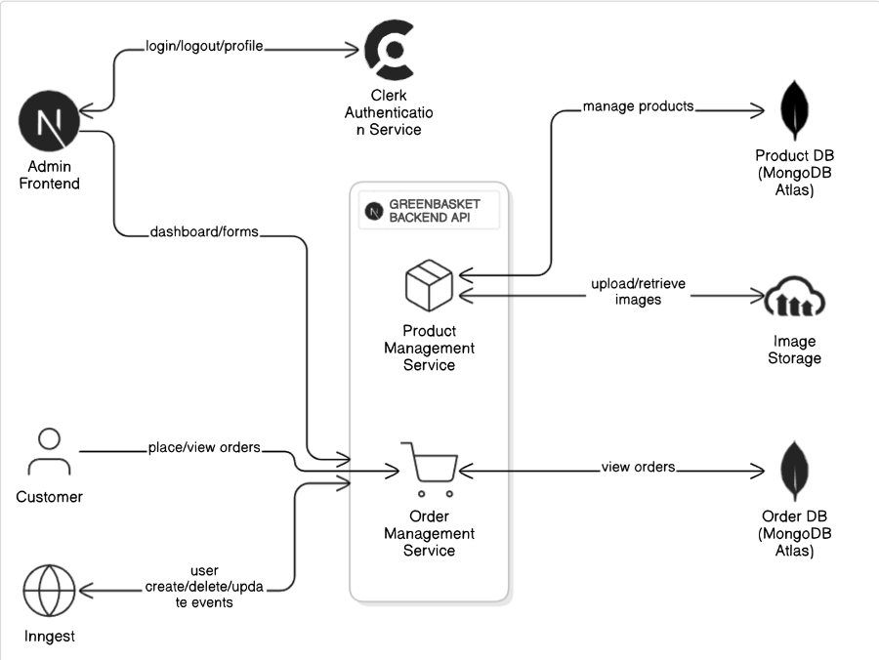

**Figure 4. 1 System Diagram**

The above system diagram for GreenBasket Backend API depicts the interactions between the Admin Frontend (handling login/logout/profile), Customer (placing/viewing orders), Inngest (user create/delete/update events), Clerk Authentication Service (auth/user CRUD), Product Management Service (managing products), Order Management Service (viewing orders), Image Storage (upload/retrieve images), Product DB (MongoDB Atlas), and Order DB (MongoDB Atlas), illustrating data flows across these components..

### 4.1.2 Context Diagram

A Context Diagram is a high-level visual representation of a system that shows the system as a single process and illustrates its interactions with external entities such as users, systems, or organizations. It is the top-level diagram in a series of data flow diagrams (DFDs) and is used to define the scope and boundaries of the system.

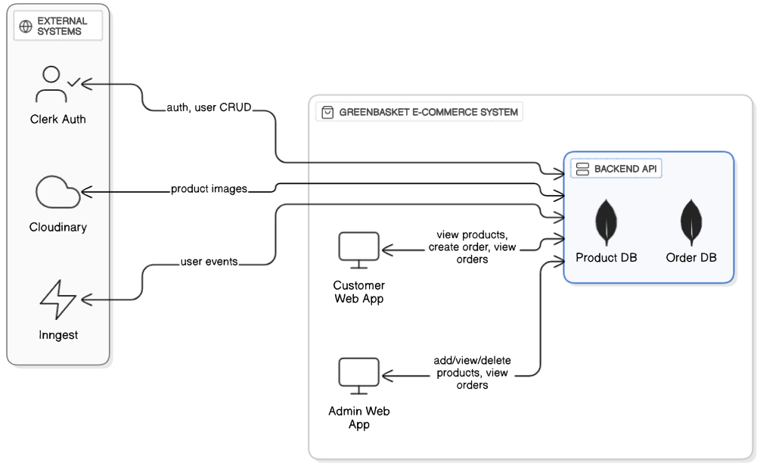

**Figure 4. 2 Context Diagram**

The above context diagram for GreenBasket E-Commerce System depicts the interactions between external systems (Clerk Auth for auth/user CRUD, Cloudinary for product images, Inngest for user events) and internal components (Customer Web App for viewing products/orders, Admin Web App for adding/viewing products/orders, and Backend API connected to Product DB and Order DB). It outlines data flows for authentication, product/order management, and image handling

# Chapter 5: Implementation And Testing

## 5.1 Implementation

### 5.1.1 Tools Used

**i) Programming Languages & Frameworks**

**Front End:**

* **Next.js:** We used Next.js to build the front part of our website. It helps make pages load faster, show up better in Google searches, and supports both server-side and static page generation. It also lets us create backend API routes easily.
* **React:** This is the main library we used to build our user interface. It helps us break the website into small parts (called components) that are easy to reuse and manage.
* **Tailwind CSS:** This is a modern styling tool we used to design our website. It helps us quickly create beautiful and responsive layouts using small utility classes written directly in the code.

**Back End:**

* **Next.js API Routes:** We also used Next.js for backend work. These routes manage tasks like product management, placing orders, and connecting to other services.
* **Clerk:** This is our login and user management system. It handles signing up, logging in, verifying users, and giving different access levels (like admin or user).
* **Cloudinary:** We used Cloudinary to store and manage product images. It keeps them sharp, loads them quickly, and works well on all devices.
* **Inngest:** This tool helps handle events like user creation, user update and user deletion.

**ii) Database Platform**

* **MongoDB Atlas:** This is the online database we used to store all our data, like user info, product details, and orders. It’s flexible, secure, and works great for online shopping platforms.

**iii) Configuration Management Tool**

* **GitHub:** We used GitHub to store our code safely, track all changes, and work together as a team on the project.

**iv) Drawing Tool**

* **Draw.io (Diagrams.net):** This free online tool helped us create diagrams like system designs, user flows, and other visuals to plan and explain our system clearly.

## 5.2 Testing

System testing is a critical process to verify that the GreenBasket software functions precisely as expected by comparing actual outcomes against predefined requirements. This testing is conducted continuously throughout the software development lifecycle to ensure high quality and reliability. For GreenBasket, we employed a comprehensive multi-level testing strategy, including Unit Testing, Integration Testing, and System Testing, to ensure the system's robustness and compliance with all specifications.

**5.2.1 Test Cases for Unit Testing**

In unit testing, individual components or modules of the software are tested in isolation. The primary purpose is to validate that each unit of software performs its designed function correctly. During the coding phase, each individual module was rigorously tested, and any identified errors were promptly debugged. Below are some key test cases for unit testing, focusing on core functionalities and Clerk authentication:

**Test Case 1: User Login**

**Table 5. 1 Test case for User Login**

|  |  |  |  |  |
| --- | --- | --- | --- | --- |
| S. No | Test Inputs | Expected Outcomes | Actual Output | Result |
| 1. | Email: customer@example.com Password: SecurePass123 | Login successful via Clerk; redirected to the customer product browsing page. | Login successful and redirected to the customer product browsing page. | Test successful |
| 2. | Email: Password:  When no email and password is provided | Clerk's validation: "Email is required" and "Password is required" error messages. | Form validation errors displayed: "Email is required", "Password is required". | Test successful |
| 3. | Email: [customer@example.com](mailto:customer@example.com) Password: wrongpass | Clerk's validation: "Invalid Credentials" error message. | "Invalid Credentials" displayed. | Test successful |
| 4. | Google Login (using a customer's Google account) | Login successful via Clerk (Google); redirected to the customer product browsing page. | Login successful via Google and redirected to the customer product browsing page. | Test successful |

**Test Case 2: Admin Login**

**Table 5. 2 Test case for Admin Login**

|  |  |  |  |  |
| --- | --- | --- | --- | --- |
| S. No | Test Inputs | Expected Outcomes | Actual Output | Result |
| 1. | Email: [shahil.bhusal3697@gmail.com](mailto:shahil.bhusal3697@gmail.com) Password: AdminPass123 | Login successful via Clerk; redirected to Admin/Seller dashboard. | Login successful and redirected to the Admin/Seller dashboard. | Test successful |
| 2. | Email: Password:  When no email and password is provided | Clerk's validation: "Email is required" and "Password is required" error messages. | Form validation errors displayed: "Email is required", "Password is required". | Test successful |
| 3. | Email: shahil.bhusal3697@gmail.com Password: wrongadminpass | Clerk's validation: "Invalid Credentials" error message. | "Invalid Credentials" displayed. | Test successful |
| 4. | Email: customer@example.comPassword: SomePass123 | "Invalid Credentials" or "Access Denied" (as this email is not the designated seller). | "Invalid Credentials" or "Access Denied" (depending on specific Clerk implementation for unauthorized role access). | Test successful |
| 5. | Google Login (using shahil.bhusal3697@gmail.com) | Login successful via Clerk (Google); redirected to Admin/Seller dashboard. | Login successful via Google and redirected to the Admin/Seller dashboard. | Test successful |

**Test Case 3: User Registration**

**Table 5. 3 Test case for User Registration**

|  |  |  |  |  |
| --- | --- | --- | --- | --- |
| S. No | Test Inputs | Expected Outcome | Actual Output | Result |
| 1 | **Method**: Email Registration **Email**: [newusera@gmail.com](mailto:newusera@gmail.com) **Password**: testpass123 **Confirm Password**: testpass123 | Clerk sends a verification code (OTP) to the provided email. User is redirected to enter OTP. | OTP sent to email. Redirected to OTP verification page. | Test Successful |
| 2 | **Method**: Email Registration **Email**: [newusera@gmail.com](mailto:newusera@gmail.com) **Password**: testpass123 **Confirm Password**: testpass12X | Clerk shows error: “Passwords do not match” | Password mismatch error displayed | Test Successful |
| 3 | **Method**: Email Registration **Email**: (empty) **Password**: (empty) **Confirm Password**: (empty) | Clerk prompts: “Email is required”, “Password must be at least 8 characters” | Validation errors shown by Clerk | Test Successful |
| 4 | **Method**: Email Registration **Email**: [existinguser@gmail.com](mailto:existinguser@gmail.com) | Clerk shows error: “This email is already in use” | Duplicate email error displayed | Test Successful |
| 5 | **Method**: Google Login **Action**: Clicks “Continue with Google” and selects an existing Google account | Clerk authenticates user via Google, auto-creates account, logs in, redirects to dashboard | Account created via Google OAuth, user logged in | Test Successful |

### 5.2.2 Test Cases for System Testing

System testing is defined as the testing of a complete and fully integrated software product. In the context of GreenBasket, system testing was performed to evaluate whether the overall platform functionalities—from user login to product interaction—meet the specified requirements. Since this is a black-box testing approach, no internal logic or code was considered during testing. Furthermore, usability testing was conducted to ensure smooth navigation and proper functioning of UI components.

**Table 5. 4 Test Case for System Testing**

|  |  |  |  |  |
| --- | --- | --- | --- | --- |
| **Test ID** | **Test Inputs** | **Expected Outcome** | **Actual Output** | **Result** |
| 1 | User logs in via Google (Clerk), browses products, adds product to cart, clicks “Place Order”. | Order should be placed immediately without payment and listed in the user’s and admin's order history. | Order placed successfully and visible in both user and admin dashboards. | Test Successful |

**Table 5. 5 Test Case for System Usability Testing**

|  |  |  |  |  |
| --- | --- | --- | --- | --- |
| Test ID | Test Inputs | Expected Outcome | Actual Output | Result |
| 1 | User clicks on links (Home, Shop, About, Contact, Cart, Dashboard). | Each link should correctly redirect to the respective page. | All links functioned properly and redirected to intended destinations. | Test Successful |

**Table 5. 6 Test Case for Admin Functionality**

|  |  |  |  |  |
| --- | --- | --- | --- | --- |
| **Test ID** | **Test Inputs** | **Expected Outcome** | **Actual Output** | **Result** |
| 1 | Admin logs in via Google (Clerk), adds a new product with image and details. | Product is listed on the product page and accessible by users. | Product successfully added and shown in the product listing. | Test Successful |
| 2 | Admin views the list of all placed orders. | All user orders are displayed in the admin dashboard with correct details. | Orders visible and properly listed. | Test Successful |
| 3 | Admin views the existing product list. | Previously added products are listed with images, names, and prices. | Product list displayed correctly. | Test Successful |

## 5.3 Result Analysis

The comprehensive testing of **GreenBasket** confirmed that all core features function reliably and meet the specified requirements. User registration and login through Clerk, including email verification and Google OAuth, were smooth and error-free. The system accurately allowed customers to browse products, add items to the cart, and place orders, which were immediately reflected in both user and admin dashboards without any payment processing issues.

Admin functionalities were verified successfully: the admin (seller) could add new products with images and details, view the complete product list, and access order histories without the ability to modify or delete existing entries, ensuring data integrity. Usability testing confirmed that all navigation links worked correctly, providing a seamless user experience across the platform.

# Chapter 6: Conclusion And Future Enhancements

## 6.1 Conclusion

The **GreenBasket** project aims to provide a seamless and secure platform for sustainable and eco-friendly shopping in Nepal. It simplifies the process of discovering and purchasing ethically sourced products, making it easy for users to find items that align with their environmental values. Beyond its core e-commerce functionalities, GreenBasket is envisioned to offer various tools and resources that enrich the user's sustainable shopping journey.

For instance, this platform could feature tips on identifying genuinely eco-friendly products, guides to understanding various green certifications, and advice on adopting a more sustainable lifestyle. It could also foster a vibrant community where users can share their experiences, exchange eco-conscious tips, and seek advice from one another.

Moreover, GreenBasket empowers sellers and administrators. Sellers can effortlessly list and manage their eco-friendly products, reaching a broader audience without incurring significant costs. The platform can also provide valuable insights to sellers, such as product view statistics, sales trends, and customer engagement metrics, enabling them to make informed decisions and optimize their offerings.

The overall impact of GreenBasket is expected to be significantly positive. By connecting consumers with safer, affordable, and sustainable products, building a supportive community for eco-conscious living, and facilitating a clearer and more efficient eco-friendly shopping process, GreenBasket is poised to make a substantial contribution to promoting sustainability in Nepal.

## 6.2 Future Enhancements

Here are future recommendations for the **GreenBasket** project, tailored to enhance both functionality and user experience, and addressing key areas for growth:

* **Mobile Application:** Develop dedicated mobile applications for both iOS and Android platforms to significantly enhance user accessibility, convenience, and engagement with GreenBasket. This will allow users to shop on the go, receive push notifications, and enjoy a native mobile experience.
* **Secure Payment Gateway Integration:** Implement robust and secure payment gateway integrations (e.g., Khalti, eSewa,) to provide users with diverse and reliable payment options. This will streamline the checkout process, improve transaction security, and enhance customer trust.
* **Robust Customer Review System:** Introduce a comprehensive customer review and rating system for all products. This feature will allow users to share their experiences, provide valuable feedback to sellers, and help other shoppers make informed purchasing decisions, fostering transparency and trust within the marketplace.
* **Advanced Product Quantity Management:** Develop and integrate a sophisticated system for managing product quantities and inventory in real-time. This will allow sellers to accurately track stock levels, prevent overselling, and enable customers to select specific quantities, leading to improved order accuracy and customer satisfaction.
* **Admin Panel Product/Order Deletion:** Enhance the administrative panel with functionalities that empower authorized administrators to delete products and manage (e.g., cancel, refund, update status) orders directly. This provides essential control over the marketplace, ensuring data integrity and efficient dispute resolution.
* **Integration of Advanced Recommendation Systems:** Implement AI-powered recommendation engines to suggest products to users based on their browsing history, past purchases, preferences, and the behavior of similar users. This will create a highly personalized shopping experience, increasing engagement and sales.
* **Expand Product Categories:** Continuously broaden the range of eco-friendly product categories available on the platform. This could include sustainable fashion, zero-waste essentials, organic food, upcycled goods, and eco-friendly services, attracting a wider audience and catering to diverse sustainable living needs.
* **Enhanced Eco-Friendly Certifications and Transparency:** Strengthen the verification process for green certifications and provide even greater transparency regarding product sourcing, manufacturing processes, and environmental impact. This will build stronger trust with eco-conscious consumers who prioritize verified sustainable practices.
* **Personalized Dashboards:** Create tailored dashboards for both customers and sellers. Customer dashboards would allow users to manage their profiles, view detailed order history, track their personal sustainability impact and receive personalized product recommendations. Seller dashboards would offer in-depth sales analytics, inventory management tools, and insights into customer engagement.

# References

|  |  |
| --- | --- |
| [1] | SAWTEE. (2022). Youth Perception Towards Sustainable Products in Nepal. Available at: <https://sawtee.org/research/youth-perception-towards-sustainable-products-in-nepal> [Accessed on: August 7, 2025] |
| [2] | EarthHero. (2024). About Us – Sustainable Marketplace. Available at: <https://earthhero.com/about-us> [Accessed on: August 7, 2025] |
| [3] | Nepal Sustainable Development Forum. (2023). Market Trends for Eco-Friendly Products in Nepal. Available at: <https://nsdf.org/market-trends-eco-products> [Accessed on: August 7, 2025] |
| [4] | UNCTAD. (2025). *Fostering environmentally sustainable electronic commerce - UNCTAD Policy Brief No. 117*. Available at: <https://unctad.org/publication/fostering-environmentally-sustainable-electronic-commerce> [Accessed on: August 7, 2025] |
| [5] | E3S Web of Conferences. (2024). *Consumer Behaviour and Sustainable Product Choices: Insights from Visual Trends*. Available at: <https://www.e3s-conferences.org/articles/e3sconf/pdf/2024/02/e3sconf_icregcsd2023_02002.pdf> [Accessed on: August 7, 2025] |
| [6] | SECOMM. (n.d.). *What is Sustainable eCommerce? How to Become a Responsible Merchant?*. Available at: <https://secomm.vn/what-is-sustainable-ecommerce-why-it-important/> [Accessed on: August 7, 2025] |
| [7] | Debutify. (2024). *Expert Tips on How to Build Trust in eCommerce*. Available at: <https://debutify.com/blog/how-to-build-trust-in-ecommerce> [Accessed on: August 7, 2025.] |
| [8] | Preprints.org. (2024). *E-commerce in Nepal: Growth, Opportunities, and Threats*. Available at: <https://www.preprints.org/manuscript/202410.1585/v1/download> [Accessed on: August 7, 2025.] |
| [9] | Cloco. (2025). *Top 10 E-commerce websites of Nepal You Should Know*. Available at: <https://cloco.com.np/blog/top-10-ecommerce-websites-in-nepal> [Accessed on: August 7, 2025] |
| [10] | NecoJobs. (2025). *Top 15 eCommerce Webites of Nepal in 2025*. Available at: <https://www.necojobs.com.np/blogs/information/top-ecommerce-sites-in-nepal> [Accessed on: August 7, 2025] |
| [11] | Prime IT Sewa. (2023). *E-Commerce in Nepal | Nepali E-commerce Market & Facts 101*. Available at: <https://primeitsewa.com/e-commerce-in-nepal/> [Accessed on: August 7, 2025] |

# Appendix

**Screenshot of GitHub Repository**

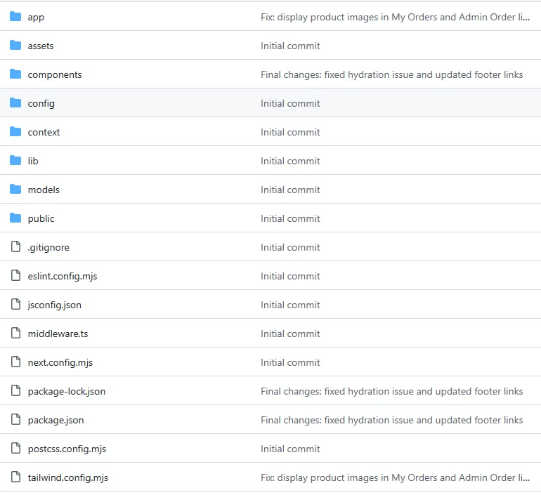

**Screenshot of Admin Home Page**

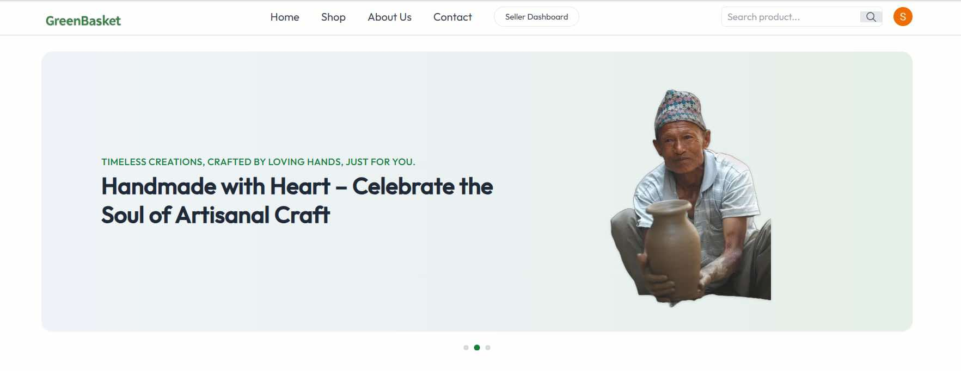

**Screenshot of Customer Home Page**

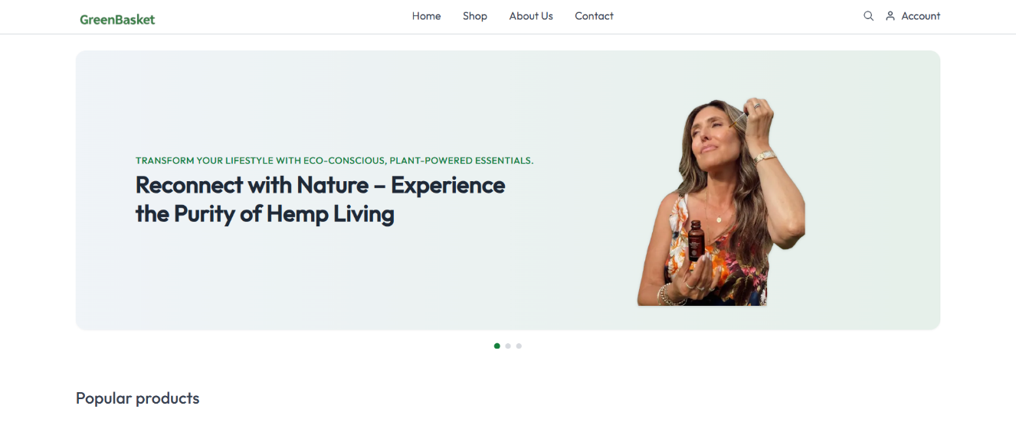

**Screenshot of Sign-In and Sign-Up Page**

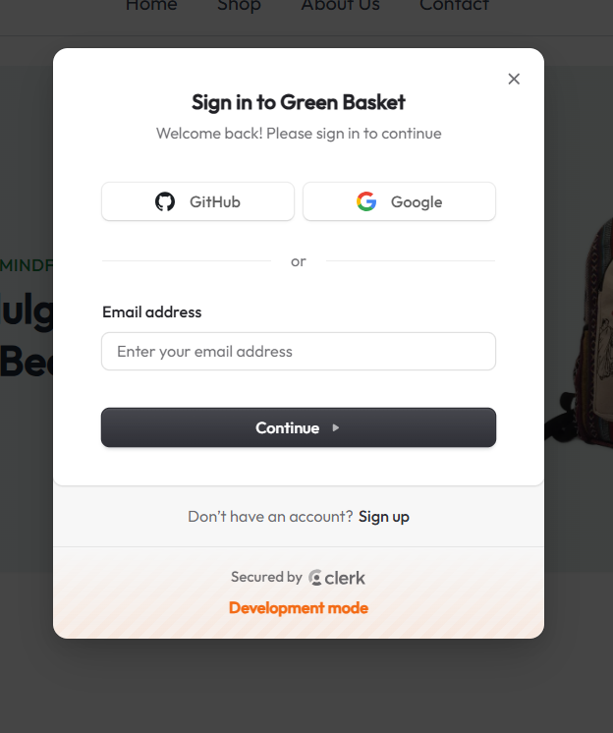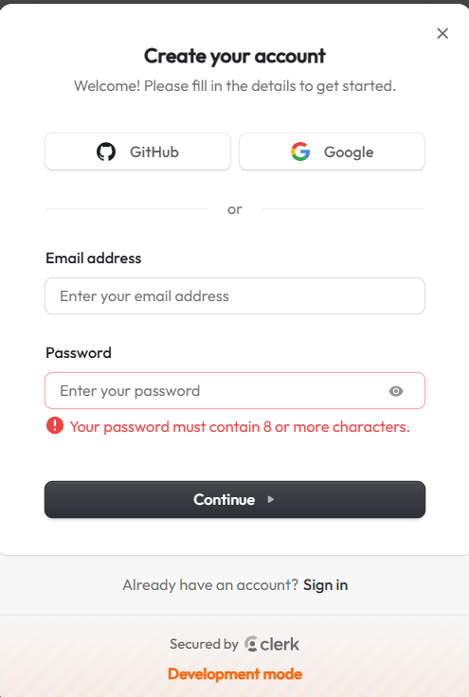

**Screenshot of Add Product Page**

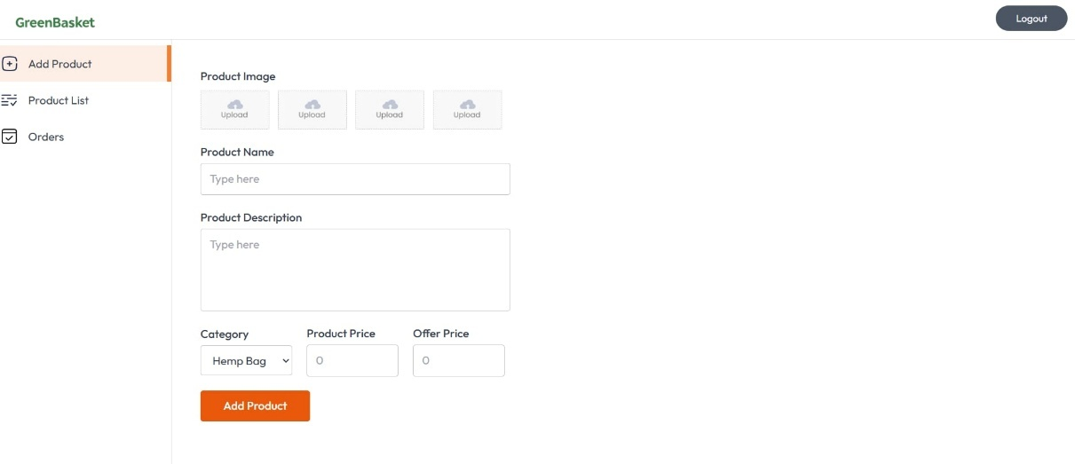

**Screenshot of Product List Page**

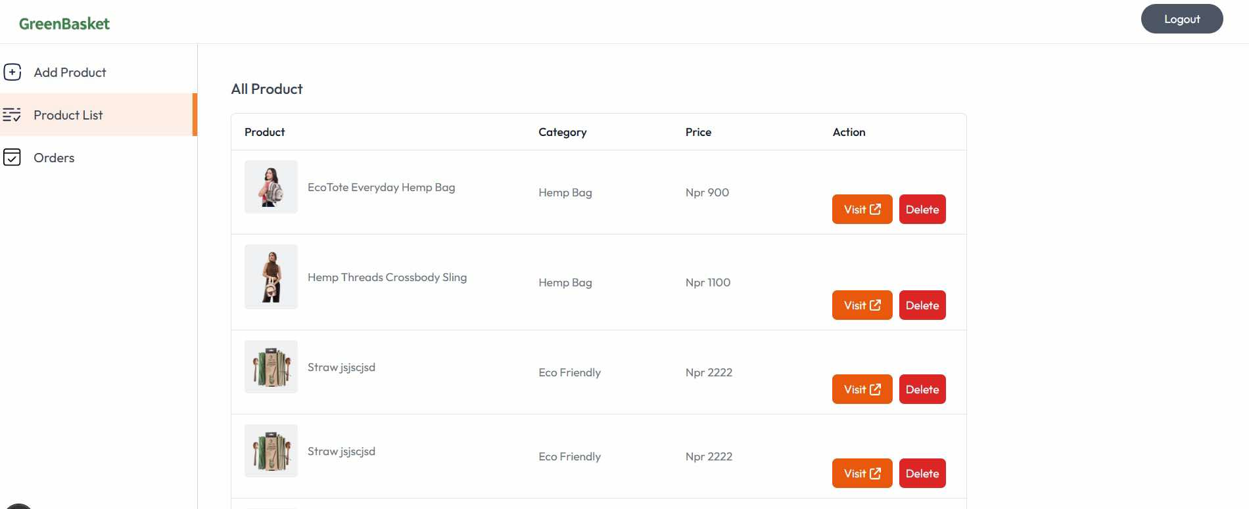

**Screenshot of Order Page**

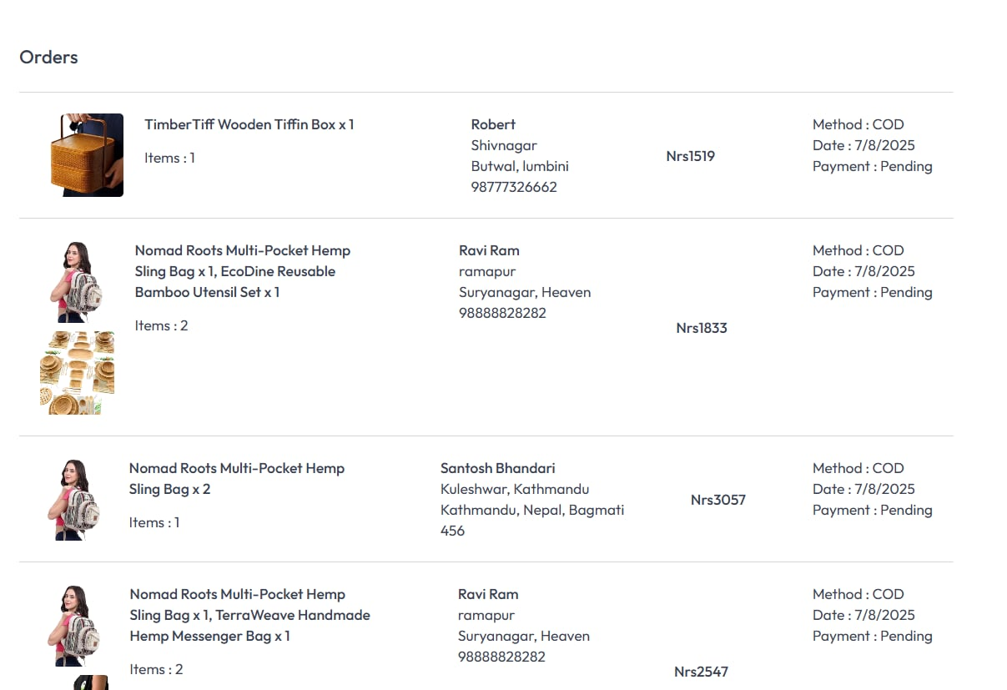

**Screenshot of Product Detail Page**

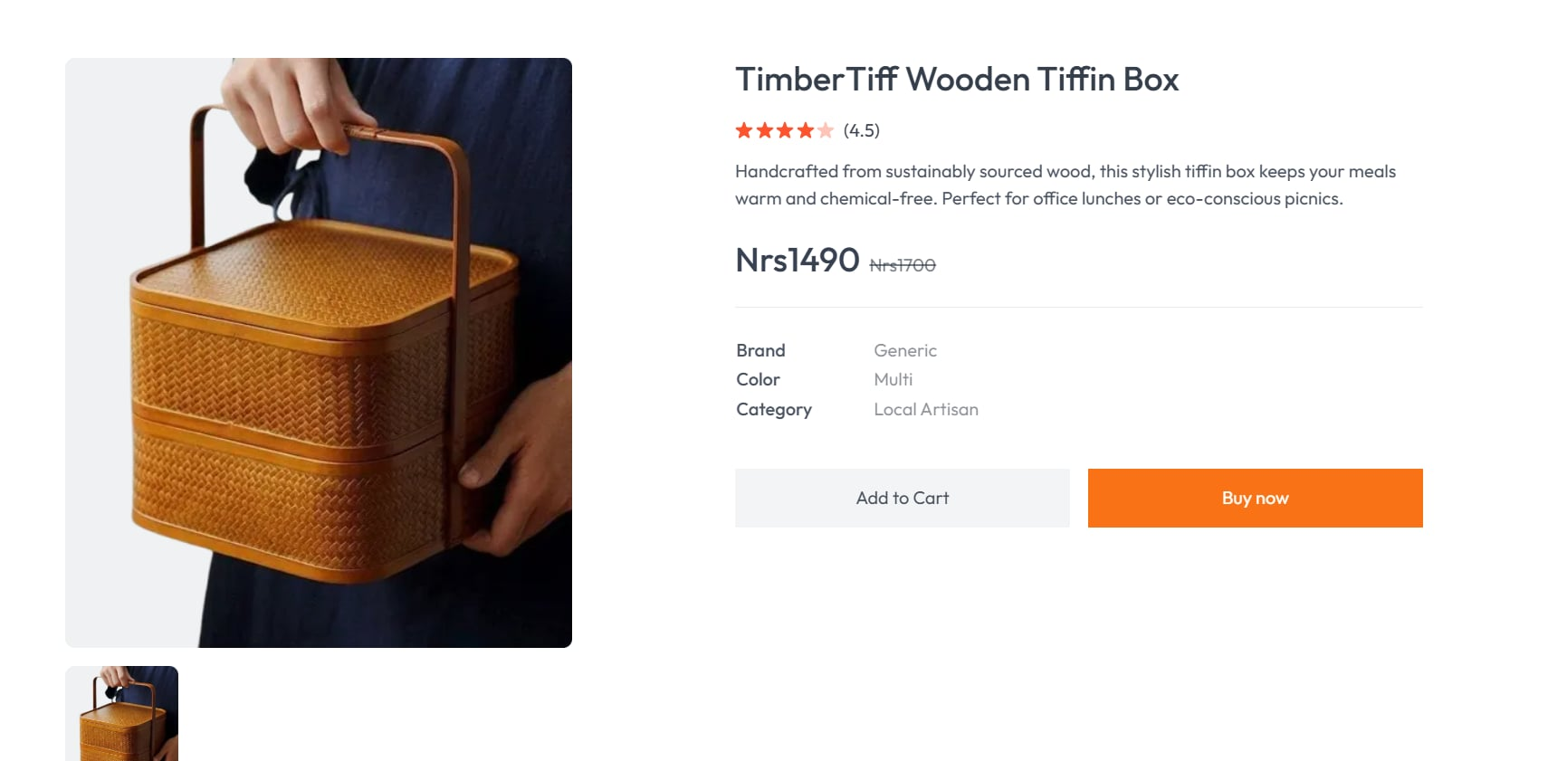

**Screenshot of Customer Order Page**

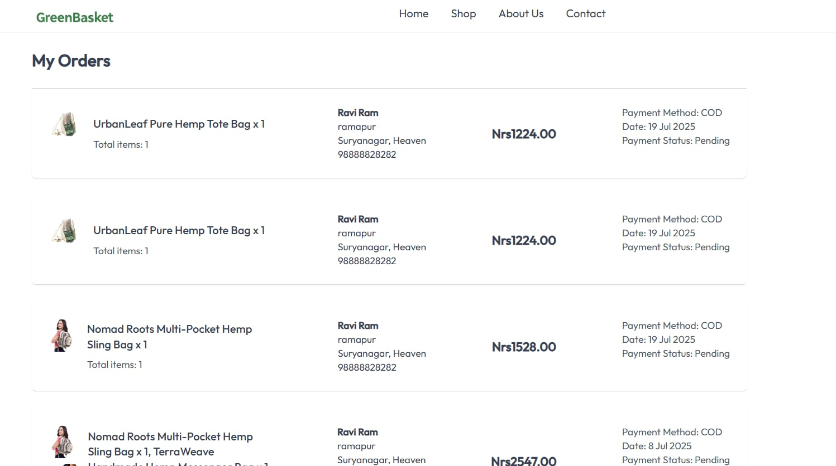

**Screenshot of Cart Page**

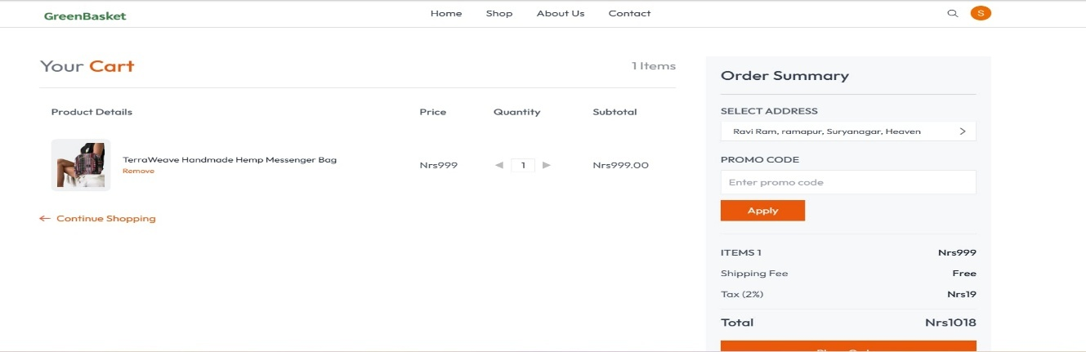

**Screenshot of Mobile View**

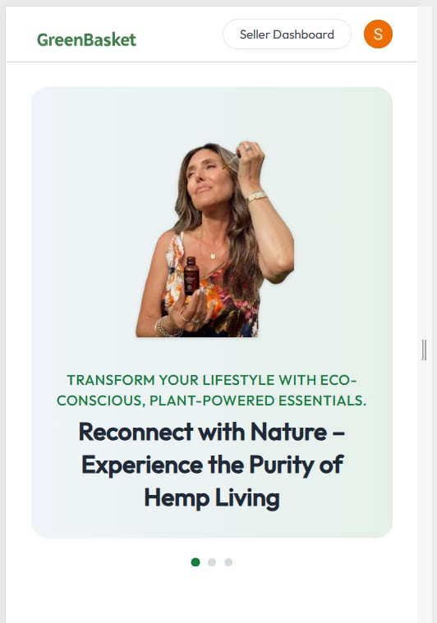 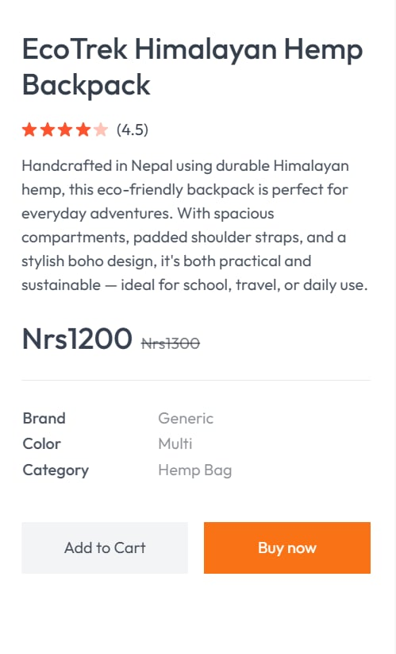

**Supervisor Log File**

**Name of Supervisor: Chiranjivi Regmi**

**Name of Project: GreenBasket “A Full-Stack E-commerce Platform for Eco-Friendly Shopping”**

|  |  |  |  |  |
| --- | --- | --- | --- | --- |
| **Date** | **Length of Session (minute)** | **Method of Supervision** | **Feedback from Supervisor** | **Signature of Supervisor** |
| 2025/02/15 | 30 | Verbal exchange | Discussion on initial project scope, technology stack (Next.js, Tailwind, Clerk). |  |
| 2025/03/01 | 20 | Direct observation | Review of Clerk integration for user authentication and initial UI/UX for product browsing. |  |
| 2025/04/10 | 20 | Direct observation | Feedback on product search functionality. |  |
| 2025/05/05 | 30 | Verbal exchange | Suggestions for improving eco-friendly product display and overall UI aesthetics. |  |
| 2025/06/02 | 25 | Direct Observation | Discussion on product quantity management and adding to cart functionality. |  |
| 2025/07/01 | 20 | Direct observation | Review of product listing process and Cloudinary integration for images. |  |
| 2025/07/15 | 25 | Direct observation | Discussion on how to implement Admin Dashboard for product and order management. |  |
| 2025/08/05 | 30 | Verbal exchange | Planning for future enhancements: payment gateway, customer reviews, admin deletion. |  |